Linux commands and their usage
- Pwd – shows your current directory
- Usage – pwd
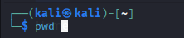

- Ls – list all the contents of the file
- Usage – ls
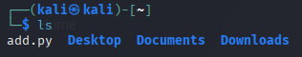

- Mkdir – make a new directory
- Usage – mkdir


- Rmdir – remove a empty directory.
- Usage – rmdir
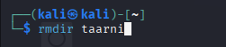

- Rm -r – remove a directory with some content,
- Usage – rm -r
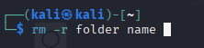

- Ls -a – list all the hidden files of the system.
- Usage – ls -a
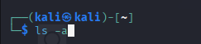

- Cd folder name – going to the folder.
- Usage – cd folder name
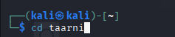

- Cd .. – going to the previous directory.
- Usage – cd ..
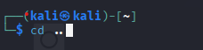

- Mousepad file name – opens the mousepad text editor.
- Usage – mousepad file name


- Rm file name – deletes the file oermanently.
- Usage – rm file name
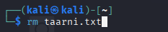

- Cat file.txt – display the contents of the file.
- Usage cat file.txt


- Whoami – shows the current logged in user
- Usage – whoami
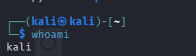

- Date – display the current date and time,
- Usage – date
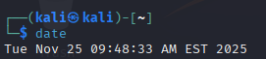

- Ping google.com – check network connection.
- Usage – ping google.com
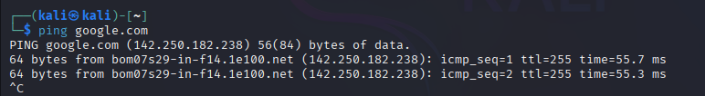

- Rm -r folder – deletes a folder and all its contents.
- Usage rm -r
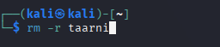

- Sudo apt install – install a new package/software.
- Usage – sudo apt install
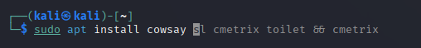

- Clear – clears the terminal screen.
- Usage – clear
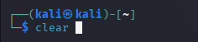

- Hirtory – shows previously used command.
- History


